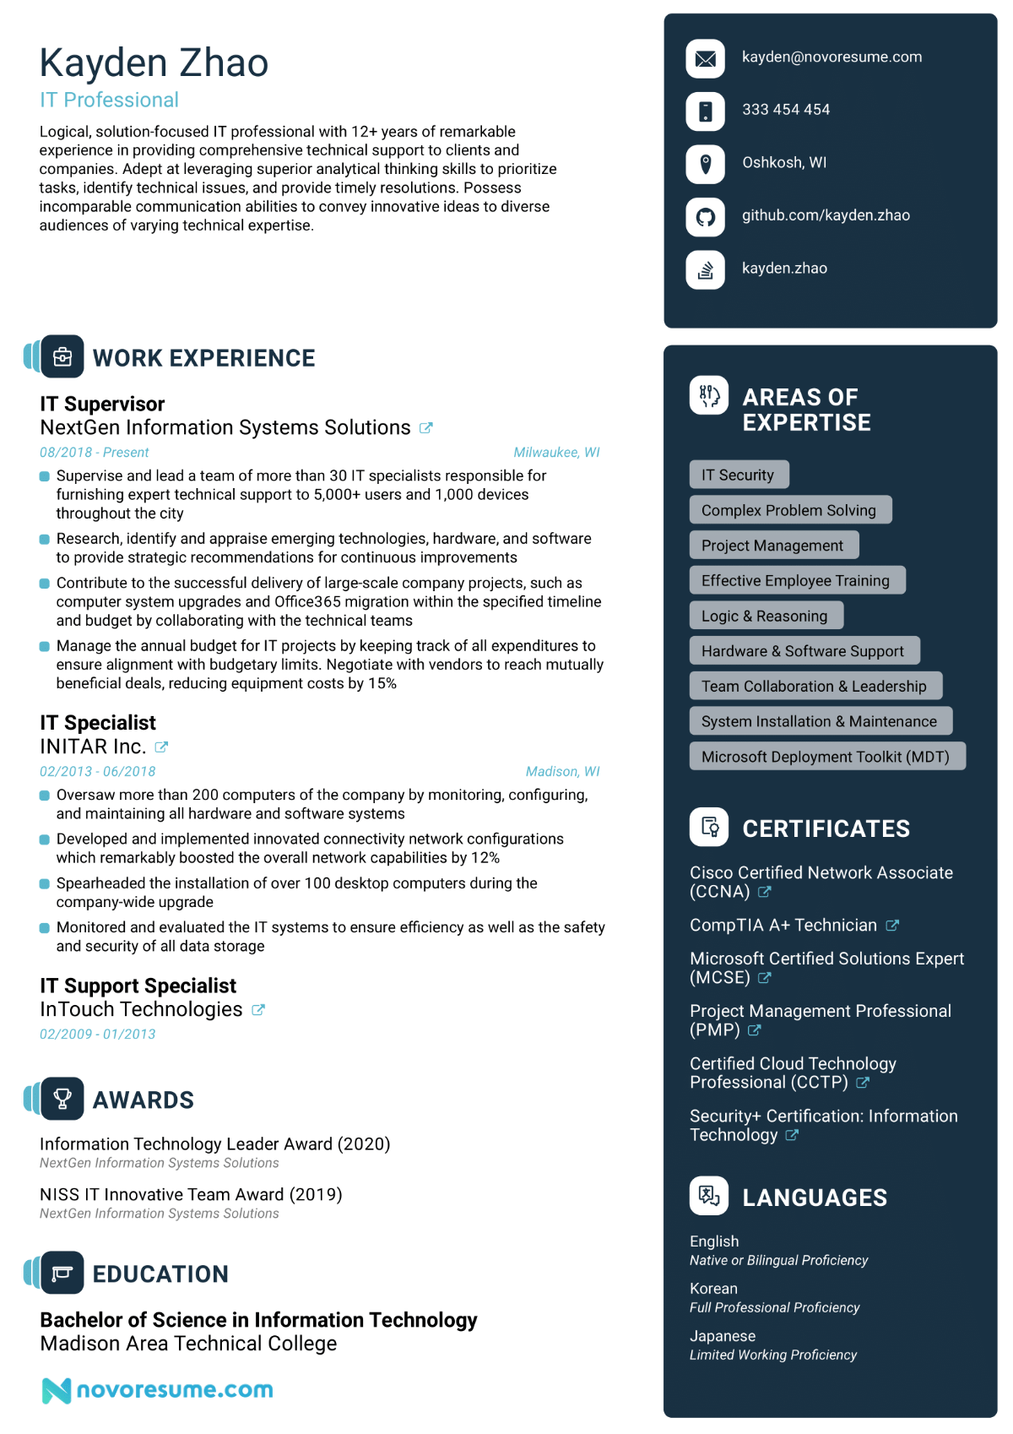
Kayden Zhao
IT Professional
Logical, solution-focused IT professional with 12+ years of remarkable experience in providing comprehensive technical support to clients and companies. Adept at leveraging superior analytical thinking skills to prioritize tasks, identify technical issues, and provide timely resolutions. Possess incomparable communication abilities to convey innovative ideas to diverse audiences of varying technical expertise.
kayden@novoresume.com
333 454 454
Oshkosh, WI
github.com/kayden.zhao
kayden.zhao
WORK EXPERIENCE
IT Supervisor
NextGen Information Systems Solutions
08/2018-Present
Milwaukee, WI
• Supervise and lead a team of more than 30 IT specialists responsible for furnishing expert technical support to 5,000+ users and 1,000 devices throughout the city
Research, identify and appraise emerging technologies, hardware, and software to provide strategic recommendations for continuous improvements
⚫ Contribute to the successful delivery of large-scale company projects, such as computer system upgrades and Office365 migration within the specified timeline and budget by collaborating with the technical teams
Manage the annual budget for IT projects by keeping track of all expenditures to ensure alignment with budgetary limits. Negotiate with vendors to reach mutually beneficial deals, reducing equipment costs by 15%
IT Specialist
INITAR Inc.
02/2013-06/2018
Madison, WI
• Oversaw more than 200 computers of the company by monitoring, configuring, and maintaining all hardware and software systems
• Developed and implemented innovated connectivity network configurations which remarkably boosted the overall network capabilities by 12%
• Spearheaded the installation of over 100 desktop computers during the company-wide upgrade
• Monitored and evaluated the IT systems to ensure efficiency as well as the safety and security of all data storage
IT Support Specialist InTouch Technologies
02/2009-01/2013
AWARDS
Information Technology Leader Award (2020) NextGen Information Systems Solutions
NISS IT Innovative Team Award (2019) NextGen Information Systems Solutions
89) AREAS OF EXPERTISE
IT Security
Complex Problem Solving
Project Management
Effective Employee Training
Logic & Reasoning
Hardware & Software Support
Team Collaboration & Leadership System Installation & Maintenance Microsoft Deployment Toolkit (MDT)
CERTIFICATES
Cisco Certified Network Associate (CCNA)
CompTIA A+ Technician
Microsoft Certified Solutions Expert (MCSE)
Project Management Professional (PMP)
Certified Cloud Technology Professional (CCTP)
Security+ Certification: Information Technology
LANGUAGES
EDUCATION
Bachelor of Science in Information Technology Madison Area Technical College
Nnovoresume.com
English
Native or Bilingual Proficiency
Korean
Full Professional Proficiency
Japanese
Limited Working Proficiency

